Competitive Shooters of Lake Norman USPSA February 19th, 2026
COURSE DESIGNER: Ike Starnes

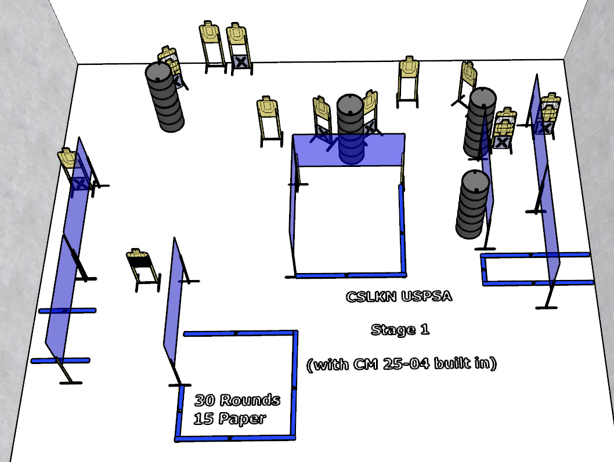

Stage 1 – The dog ate my homework
30 rounds, 150 points, Comstock
There are 15 cardboard targets with some no-shoots.
Start position is anywhere you want
Handgun is loaded holstered with wrists below belt.
PCC is loaded and held with both hands and stock touching belt.
On the audible start signal, engage targets from within the shooting area.

